~ Please refer to the zip file for source code.

** **Requirements to run the program**

1. Xampp Server

* The source code should be place at “**C:\xampp\htdocs**” for proper functioning.

1. SQL query attached to the Zip folder

* The database name is set to `bookstore`.
* After creating database SQL queries can be imported for easy access.

1. After all these steps website and database can be accessed from:

* Website: <http://localhost/BookStore/index.php>
* Database:<http://localhost/phpmyadmin/index.php?route=/database/structure&db=bookstore>

1. **Screenshot of Website:**

* **Home page**

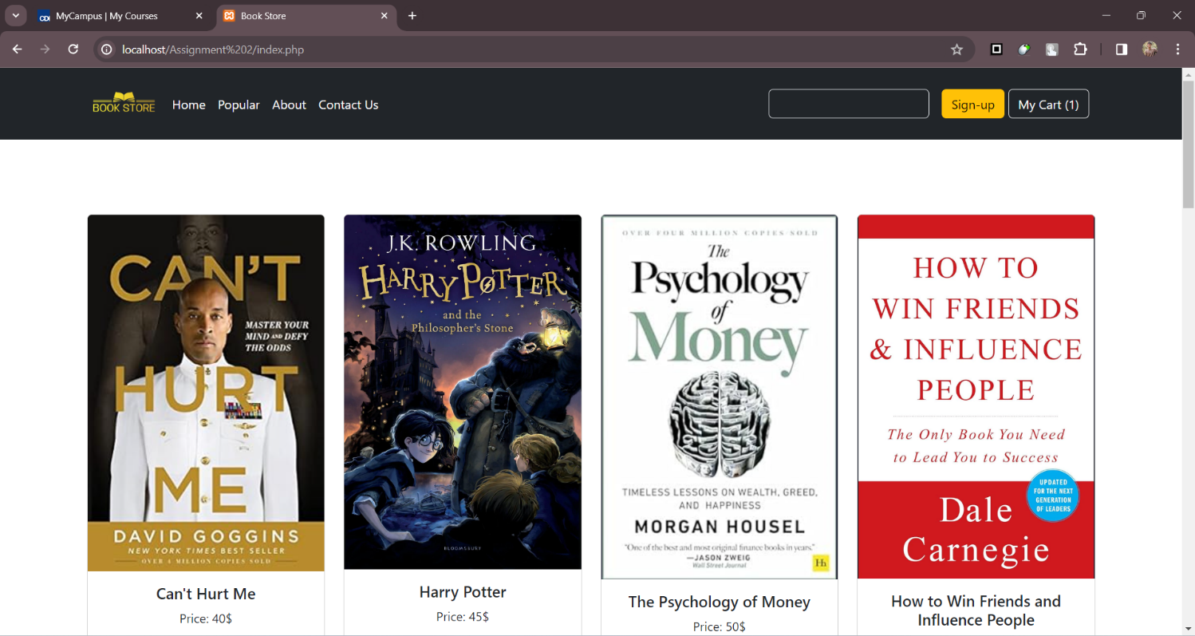

* **Popular Page**

* **About Page**

* **Contact Us Page**

* **Sign-Up Page**

* **My Cart Page**

1. **Database Screenshot**

